Rivercrest Early Learning and Childcare Snack Menu | Monday | Tuesday | Wednesday | Thursday |   Friday
Week 1
A.M Snack | 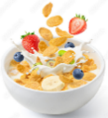  Cereal  Fruit  Milk | Bagels  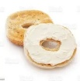  Cream Cheese  Fruit  Water | Yogurt  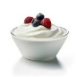  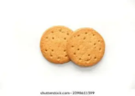  Digestive Cookies  Fruit  Water | Rye Toast  Applesauce  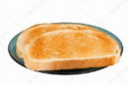  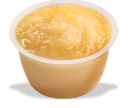  Milk | Muffins  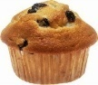  Fruit  Milk
P.M Snack | Pizza Buns  (Bun, pizza sauce, cheese and pepperoni)  Water  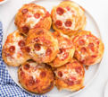 | Cheese  Crackers  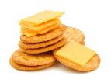  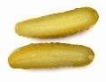  Pickles  Water | Rice Krispie Square Bars  Fruit  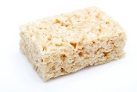  Milk | Mac and Cheese  Cooked Frozen Vegetables  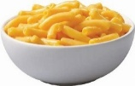  Water | 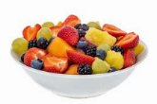  Goldfish  Fruit Salad Water
Week 2
A.M Snack | 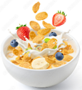  Cereal  Fruit  Milk | Cinnamon Buns  Fruit  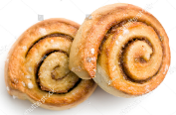  Milk | English Muffins  Jam & Fruit  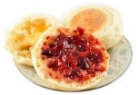  Milk | Bagels with Cream Cheese  Fruit  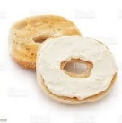  Water | Yogurt  Granola  Fruit  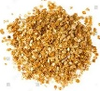  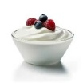  Water
P.M Snack | Animal Crackers  Fruit  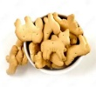  Milk | 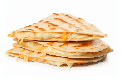  Pizza Quesadilla  Carrots and Cucumber with di & Water | Pudding  Fruit  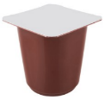  Water | Nachos with Cheese w/ Salsa  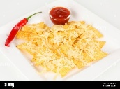  Peppers &Water | Sorbet  Berries  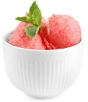  Water
Week 3
A.M Snack | Cereal  Fruit  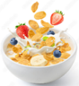  Milk | Nutrigrain bars  Fruit  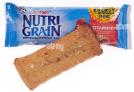  Milk | English Muffins  Fruit & Milk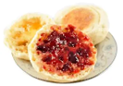 | Homemade Bread  (Banana, apple, cinnamon, etc.)  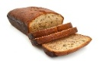  Fruit & Milk | Toast w/ Wow Butter or Jam  Banana & Milk  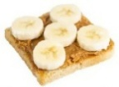
P.M Snack | Apple Sauce  Graham Crackers  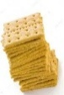  Milk  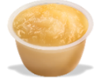 | Chex Mix (“Nuts” and Bolts)  Veggie and Dip  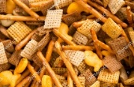  Water | Fruit Smoothie  Granola Bars  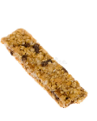  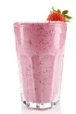  Water | Grilled Cheese on Whole Wheat bread with Veggies and Dip  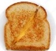  Water | Pretzels (Goldfish-INF) Hummus  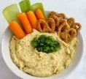  Peppers, Milk
Week 4
A.M Snack | Cereal  Fruit & Milk  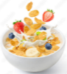 | English Muffins  Jam & Fruit  Milk | Waffles  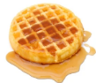  Fruit & Milk | Rye Toast  Jam & Fruit  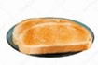  Milk | Muffins  Yogurt  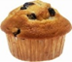  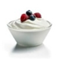  Fruit & Water
P.M Snack | Trail Mix  Apples and Wow Butter  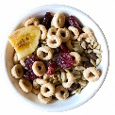  Milk | 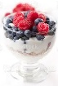  Yogurt Parfaits with Granola and Frozen Fruit  Water | Homemade Cookies  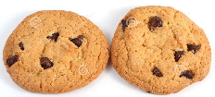  Fruit & Milk | Hot Dogs  Veggie Slices  Milk  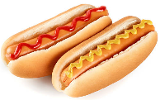 | Rice Crackers  Cheese  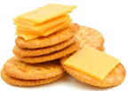  Veggies  